An Overview of Webmail

www.HostingEmails.com

Table of Contents

What browsers can I use to view my mail? 3
Email size and storage limits 3
Composing a new message 4
Adding attachments to a message 8
Inserting a hyperlink 9
Searching for messages 11
Downloading email from a POP3 account 12
Forwarding email 14
Managing Address Book contacts 18
Addressing email messages to contacts 19
Importing and exporting contacts 21
Importing contacts 23
Viewing email headers 25
Using the Allowed and Blocked Senders lists 25
Creating an email signature 27
Enabling an auto-reply message 30
Changing your email password 31
What languages are available in Webmail? 32
Changing the Webmail language 33
Setting the time zone 34
File storage and sharing files 36
Restoring deleted email 41
Customizing your spam settings 41
Using the calendar 44
Calendar Sharing 46
Clearing the cache and cookies from your web browser 48
Internet Explorer 49
Mozilla Firefox 51
Google Chrome 52

This tutorial is our how-to guide for using Webmail. It does not cover every aspect of Webmail; instead, it focuses on some of the most popular features.

What browsers can I use to view my mail?
The following browsers support Webmail:

- Microsoft Internet Explorer 7.0 and higher
- Mozilla Firefox 2.0 and higher
- Chrome 1.0 and higher
- Safari 3.2 and higher
- Konqueror 3.5 and higher
While basic webmail features will work on mobile browsers (e.g. iPad, Android Tablet), the full webmail feature set is not officially supported on mobile browsers. We recommend mobile users to use the basic interface.
Note: You may be able to view the Webmail interface on other, unsupported browsers; however, some features may produce unexpected results.

Email size and storage limits

All e-mail accounts provide 5 GB of server side storage for archiving messages. You can send messages up to 25 MB in size.

The maximum size for email messages, including any attachments, is 35 MB; however, when attachments are sent over the Internet, they must be encoded, and this encoding increases the size of the message. The size increase can sometimes be more than 25 percent.

We recommend that you not try to send attachments that are larger than 25 MB. If you want to share large files, we recommend that you use the Files feature that is part of Webmail.

In addition, some mail servers will not accept large email messages, so if you attach a large file to your message, it may not reach its intended recipient.

Composing a new message
1. Click Mail, and then click Compose.
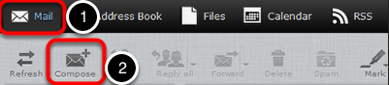

2. In the To field, enter the email addresses to which you want to send the message (separate multiple addresses with a comma).
Alternatively, in the Contacts pane on the left side, select one or more addresses from your saved contacts list, and then click the To button at the bottom of the pane.
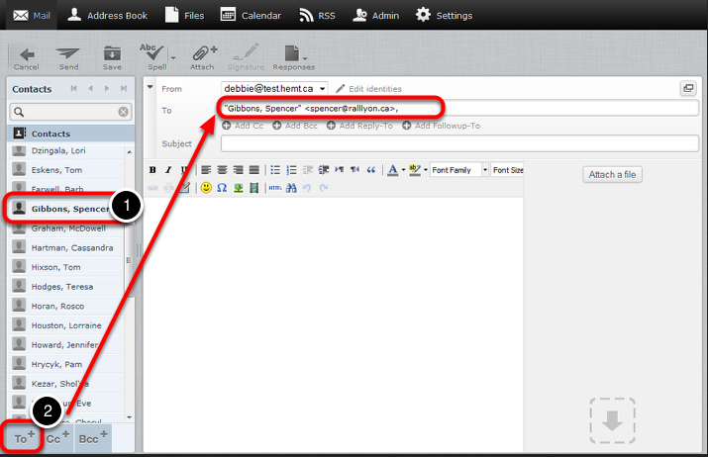

3. You can send a copy of the message to other addresses by entering the addresses in the Add Cc field as described above.

In the example below, the message is addressed to "info@rallyon.ca". The recipient "spencer@rallyon.ca" will receive a copy of the message and (along with any other recipient listed in the Cc field), will be able to see that the message was sent to "info@rallyon.ca"

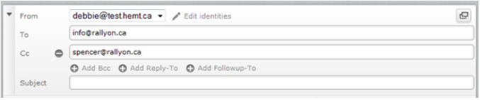
You can also send a blind carbon copy of the message to other addresses by entering the addresses in the Add Bcc field as described above.

In the example below, the message is addressed to "info@rallyon.ca". The recipient "spencer@rallyon.ca" will receive a copy of the message and will be able to see that it was sent to "info@rallyon.ca". However, none of the recipients (in the To, Cc or Bcc fields) can see that a Bcc (blind carbon copy) was sent to "mdoucette@potpourri.com" and "peziza@hotmail.com".
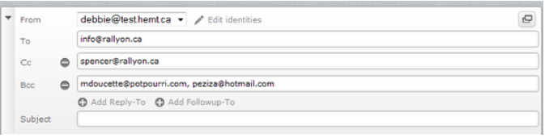

- In the Subject field, enter a subject for your email message.
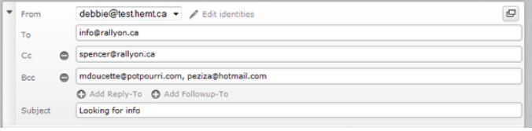
5. In the large text area below, type the body of your message.
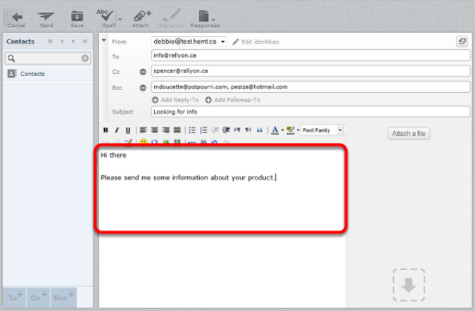

- When you are finished writing your message, click Send to send your message.
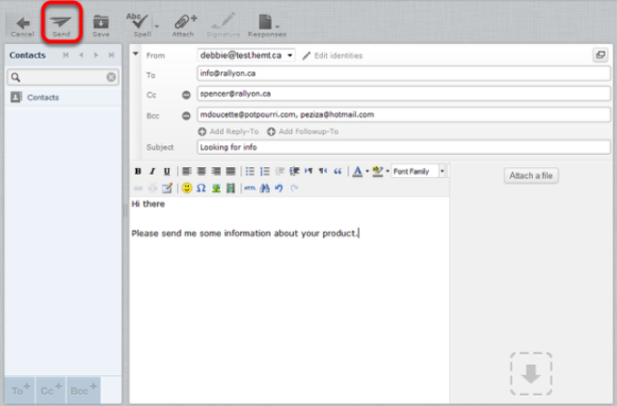

Adding attachments to a message

1. While composing an email message in Webmail, click Attach a file. You can find this option in the toolbar and in the message area, and you can click either one.
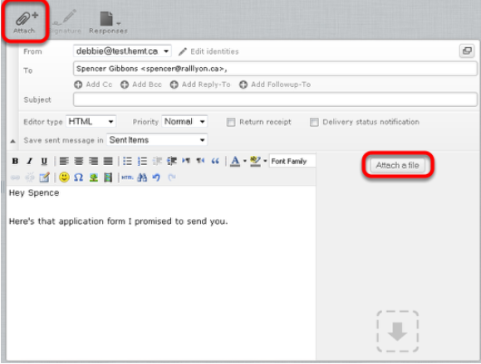

- From the pop-up window, select the file you want to attach to your message, and then click Open.
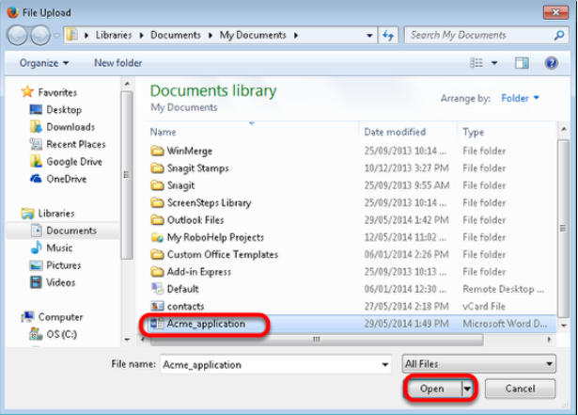

- Click Upload.
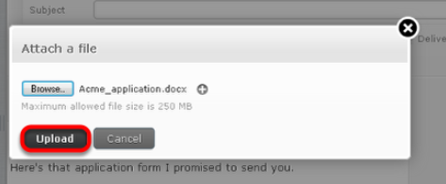
The file is now attached to the message.
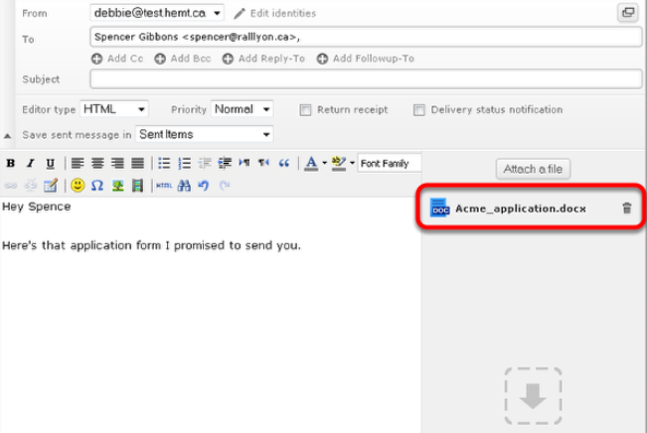

Inserting a hyperlink

You can insert hyperlinks in your messages so that, when the recipient clicks on the link, the associated web page opens.

To insert a hyperlink in an email

1. In the body of your message, enter the text that you want to make into a hyperlink.
This can be the actual location or URL (such as http://www.example.com) or any text (such as click here).

- Highlight the text by holding down the left mouse button as you drag the cursor over the text.

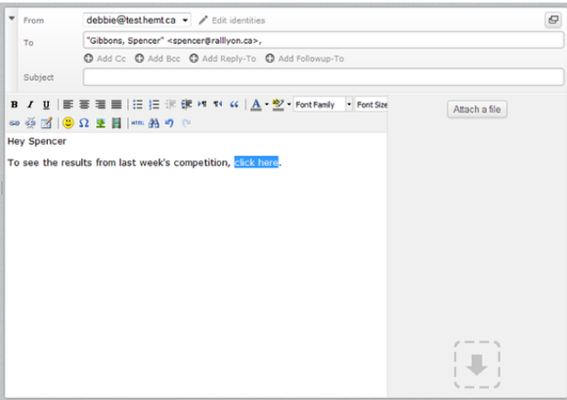

- Click the Insert/Edit link icon.

The Insert/Edit Link window appears.
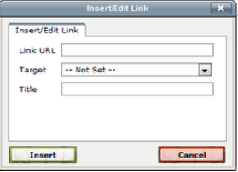
7. Click Insert.

Searching for messages

This tutorial will show you how to search for a specific message in Webmail.

1. In the Mail folders section, select the folder that you want to search.

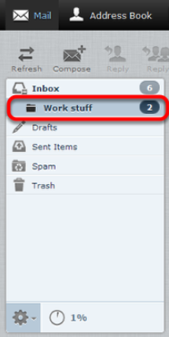

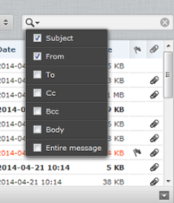
- From the search drop-down list in the top-right corner of the window, select the type of search criteria you want to use.

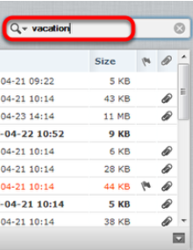
3. Type your search criteria in the search field and then press Enter.
Any messages in the selected folder that match your search criteria are displayed.

Downloading email from a POP3 account

This tutorial will show you how to download messages from another email account into Webmail using POP3.

To set up a POP3 account in Webmail, complete the following steps:

- Click Settings.
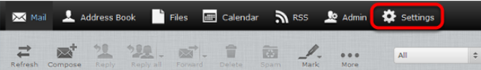
2. Click Preferences, and then click Other Accounts.
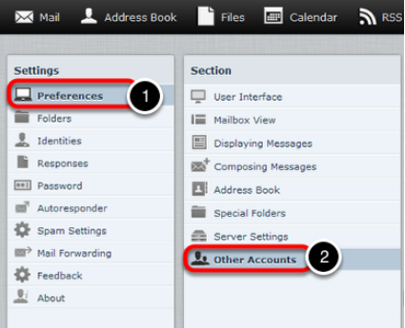
3. In the Other Accounts pane, click Add.
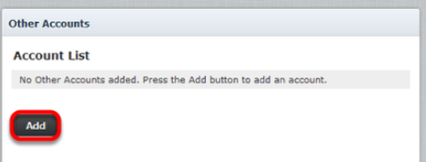
4. Complete the fields on the Add POP3 Account page as follows:

- Email—Enter the full email address of the other account.
- Username—Enter the username you use to log in to your other email account.
- Password—Enter the password you use to log in to the other email account.
- Provider—From the drop-down list, choose the account's service provider.
- Server Address—The server address can be obtained from the provider of the email account you are trying to download.
- Server Port—Use port 110 if you do not put a check in the Use SSL box. Use port 993 if you do put a check in the Use SSL box.
- Use SSL—Putting a check in this box will make Webmail access your other email account through an encrypted connection.
- Leave Messages On Server—Put a check in this box if you want to leave a copy of the messages you download in the original email account.
- Default Folder—Select the folder to which you want to download the messages from your other email account.
- Test connection on save—Click to put a checkmark in this box if you want to test the connection to this account when you save the configuration.
- Import old messages—Click to put a checkmark in this box if you want to import all existing messages from the account. If you don't select this option, only new, unread messages will be imported.

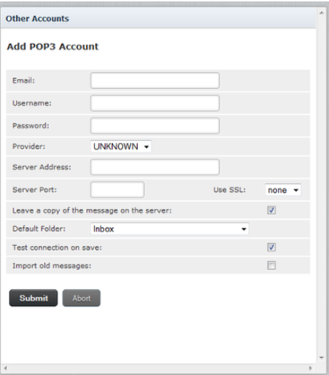

- Click Submit.

Forwarding email
This tutorial will show you how to automatically forward email from your Webmail address to another email address.

Note: Email that has been identified as spam by our system will be trapped by the Webmail Spam filter and will not be forwarded. The reason for this is that when a piece of spam email is forwarded by our server, the receiving server considers us to be the source of the spam even though we weren't the original sender. If too much spam email is forwarded by our system, it can result in our forwarding server being blacklisted. Blacklists temporarily prevent any email from being forwarded for all email addresses in our system. This is extremely disruptive to our customers. By filtering email for spam before forwarding, we are able to provide a more reliable email forwarding service.

If email from legitimate senders is going to your Spam folder, you can add their email addresses or domains to your Allowed Senders list. This will mark all email from those senders as safe and all new messages from those senders will be forwarded.
For more information, see "Using the Allowed and Blocked Senders lists".

To forward email from your email account to another email address

1. Click Settings.
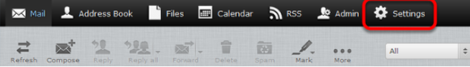

- In the Settings pane, click Mail Forwarding
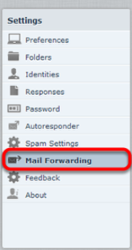

3. In the Forwarding Recipients text box, enter the addresses to which you want to forward your messages. Be sure to separate multiple addresses with a comma.

4. Click to put a check in the Enabled box.

- Optionally, to leave a copy of forwarded messages in your Webmail account, click to put a check in the Keep local copy box.
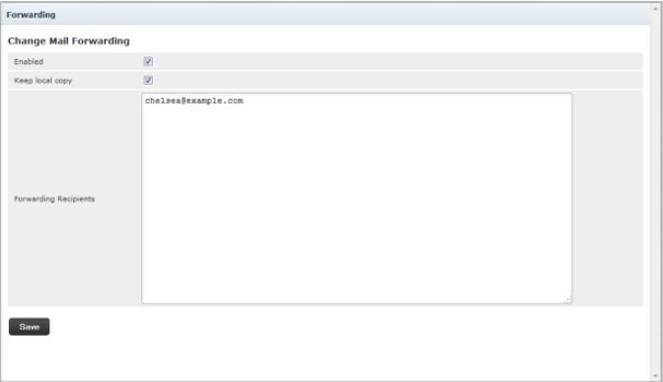
6. Click Save.
Working with Webmail folders

This tutorial will show you how to work with your Webmail folders.
Viewing message contents of a folder

Your Webmail folders are listed on the left hand side of the Webmail screen. Click a folder to view its messages.

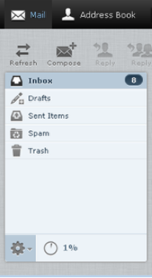

Moving messages to another folder

To move multiple messages from one folder to another folder

1. Click the folder that contains messages you want to move.

- Select the messages that you want to move.

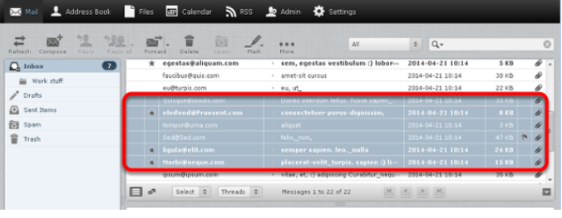

To select multiple contiguous items, select the first item, hold down the Shift key, and then click the last item. To select multiple non-contiguous items, hold down the key and click on each of the items that you want to select.

3. Right-click and choose More, then Move to, and then choose the folder to which you want to move the files.
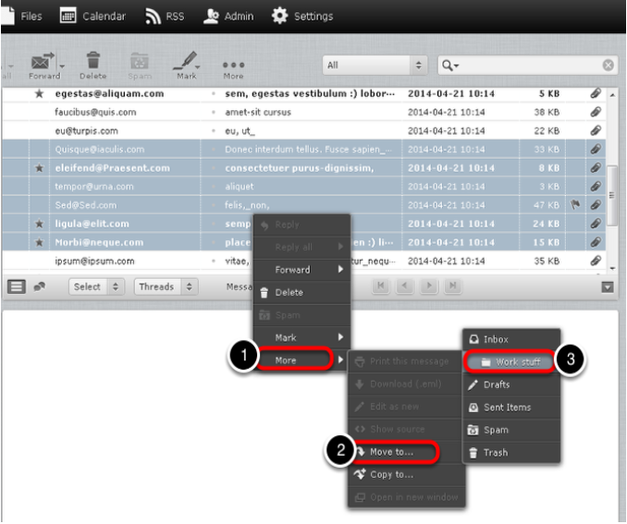

Managing Address Book contacts

This tutorial will show you how to manage your Address Book contacts.

Adding contacts

- Click Address Book.

- At the bottom of the Contacts list, click the Create new contact card icon.
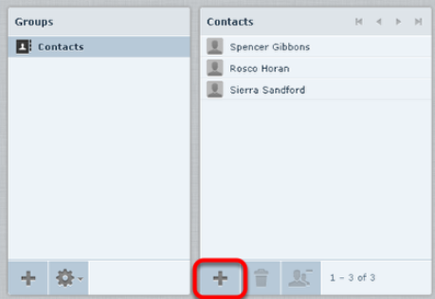

3. On the Add new contact pane, enter the relevant contact information, then click Save.
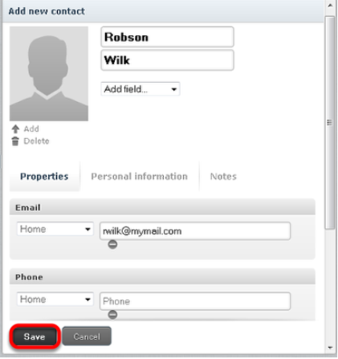

Addressing email messages to contacts

There are several ways to use the Address Book to address email messages.

- Click Mail and then click Compose to start a new message. In any of the recipient fields (To, Cc, Bcc, Reply-To, and Followup-To), start typing the name of a contact that is in your address book. A list of the contacts whose name includes those letters appears in a list format. Click the name you want to add to that field.

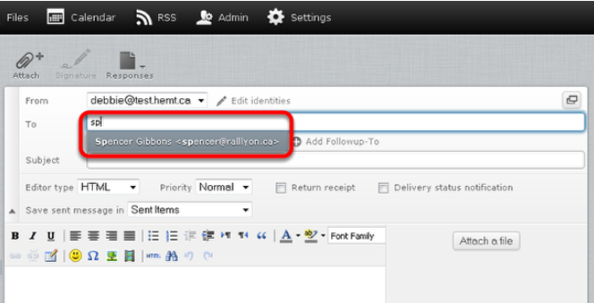

- Click Mail and then click Compose to start a new message. Click the Contacts list in the left pane to display all of the contacts that are saved in your Address Book, and then choose one or more contacts. To select multiple contiguous contacts, select the first one, hold down the Shift key, and then click the last one. To select multiple non-contiguous contacts, hold down the Ctrl key and click on each one that you want to select. Click an icon at the bottom to choose whether to put the selected contact addresses in the To field, the Cc field, or the Bcc field.

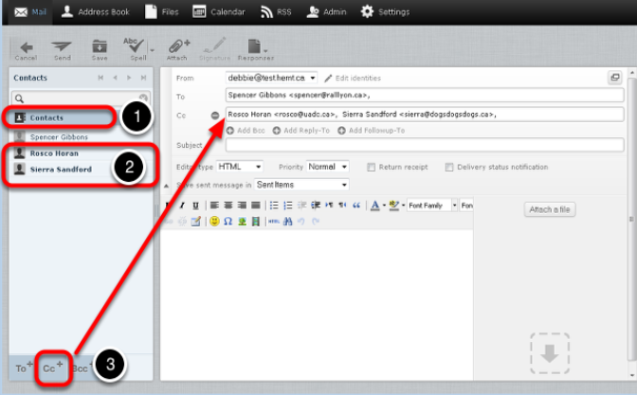

- Click Address Book, and then from the Contacts list, select one or more of the contacts to whom you want to send a message. Right-click, and choose Compose.

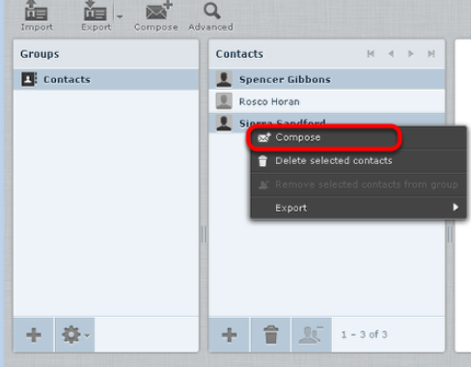

Importing and exporting contacts

This tutorial will show you how to export your Webmail contacts into another mail program.

Exporting contacts

Contacts can be exported in vCard format; the filename ends with.vcf.

To export contacts:

1. Click Address Book

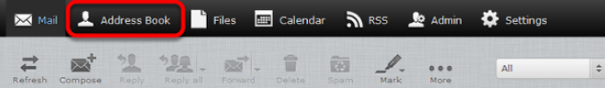

2. From the Groups pane, choose the group that contains the contacts that you want to export.
Select Contacts if you want to export all of the contacts in the Address Book.

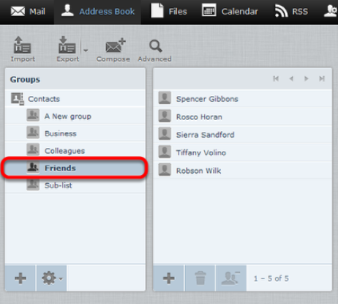

3. Optionally, click to select the individual contacts that you want to export.

To select multiple contiguous items, select the first item, hold down the Shift key, and then click the last item. To select multiple non-contiguous items, hold down the Ctrl key and click on each of the items that you want to select.

- From the Export drop-down list, choose Export all or Export selected.
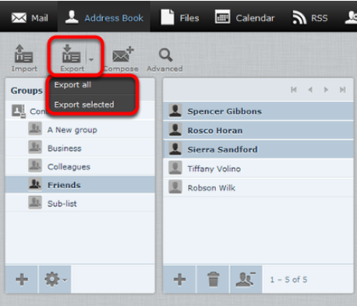

5. Choose where to save the exported file if prompted; otherwise, check the Downloads folder on your computer for a file called contacts.vcf.
Importing contacts

You can import contacts from either vCard (.vcf) files or CSV files.

To import contacts:

1. Click Address Book.
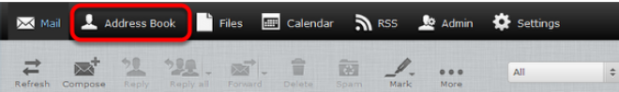

2. Optionally, select the group into which you want to import the contacts.
If you don't select a group, the contacts will be imported into the Contacts group only.
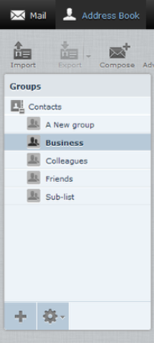

3. Click the Import icon

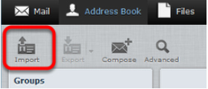

- Click Browse and navigate to the contacts file that you want to import. Select the file, and then click Open.
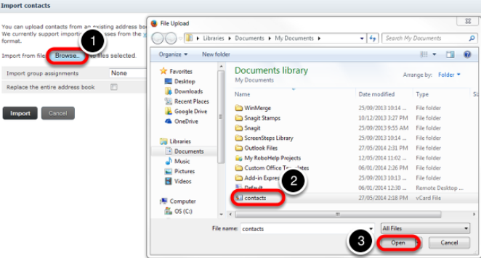

- From the Import group assignments drop-down list, select which address book the contacts should be imported to. The Replace the entire address book checkbox lets you delete all contacts from the selected address book before importing. Be careful with this option; the deletion cannot be undone!

- Click Import.

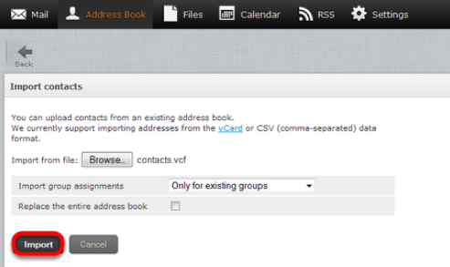

Webmail imports the contents of the file and assigns the contacts to the master Contacts group and to any selected groups.

Viewing email headers

This tutorial will show you how to obtain the full headers from your email messages in Webmail. Viewing headers is useful for troubleshooting issues such as email delays, spam, viruses, and abuse issues.

- Display the message and then click Toggle Raw Message Headers.

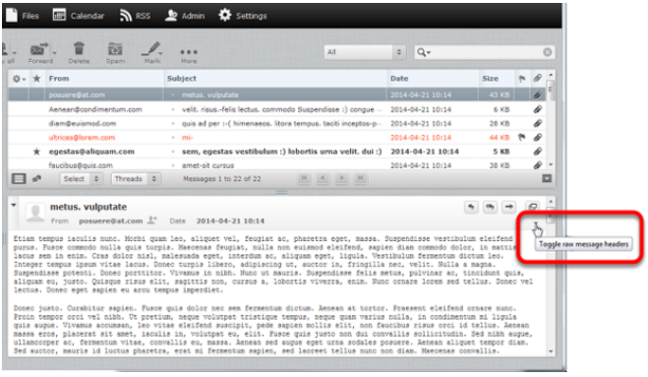

A window appears that contains the Internet headers as well as the content of the email message. If the email was sent as HTML you will also see the HTML source of the message.

Using the Allowed and Blocked Senders lists

Webmail provides a tool that allows you to block or allow email from specific senders. You can add up to 1000 entries in the Blocked Senders list and 1000 entries in the Allowed Senders list.

Make sure that you enter the sender's email address or domain as it appears in the sender's "Return-Path." The return path is in the first line of the email headers. This may not be the same as the address that is displayed in the From field of the message.
For information on how to view email headers, click here: "Viewing email headers"

Note: If you see the following error message when trying to add an address to your Blocked or Allowed list, you have reached the maximum address limit.
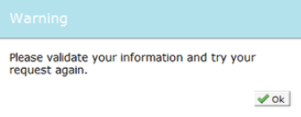

If this happens, you should consider revising your Allowed Senders and Blocked Senders lists to fit within the limit. Replacing multiple addresses that are in the same domain with a wildcard (*) is one way to trim down these lists.

If you want to add a domain to the Allowed or Blocked Senders list, the domain name must be preceded by *@ (for example, *@example.com).

Important: Be careful when adding entire domains to your list. If you add something like *@hotmail.com to your Blocked Senders list, you are blocking every single sender with a hotmail address.

Adding senders to the Allowed or Blocked lists

To add senders to the Allowed or Blocked Senders lists.

1. Click Settings.
Adding senders to the Allowed or Blocked lists

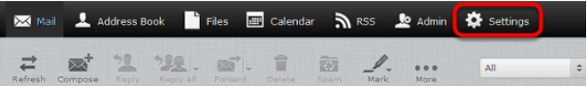

2. In the Settings pane, click Spam Settings.

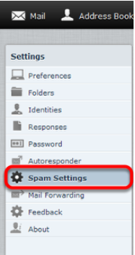

3. In the Allowed Senders or Blocked Senders text box, enter the email addresses that you want to allow or block, and then click Save.

Creating an email signature

An email signature automatically inserts a standard footer at the bottom of all outgoing email messages.

This tutorial will show you how to create and enable an email signature.

1. Click Settings.

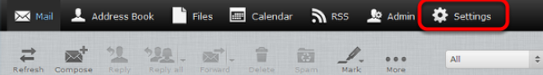

2. In the Settings pane, click Identities, and then click the account for which you to create a signature.

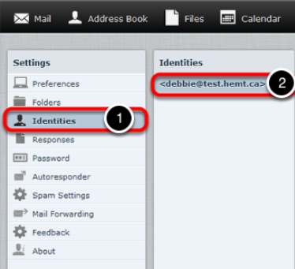

3. Enter your email signature in the Signature text box.

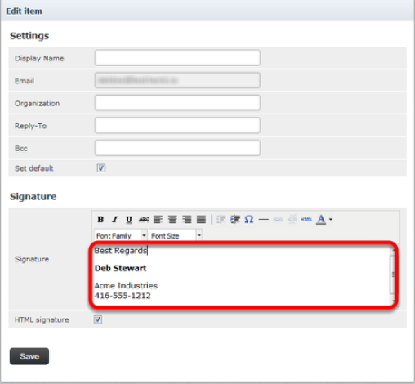

4. If you primarily send formatted (HTML) messages, you can enable the HTML signature option which allows you to add formatting of your signature; when HTML signature is selected, the Signature text box displays a formatting toolbar.

5. Click Save.

6. In the Settings pane, click Preferences and then click Composing Messages.

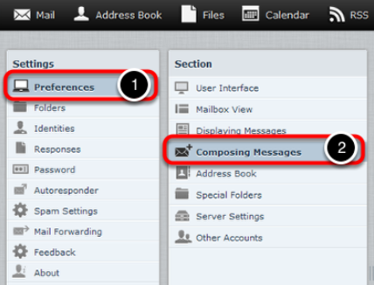

7. In the Signature Options section, from the Automatically add signature drop-down list, choose the option to specify the way you want to display your signature:

never—Do not display the signature.
always—Display the signature on all messages, including new messages, replies, and forwards.
new message only—Display the signature on new messages, but no on replies or forwards.
replies and forwards only— Display the signature on replies and forwards but not on new messages.

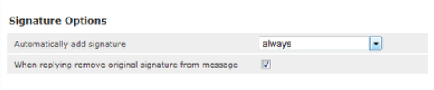

8. Click Save.

Enabling an auto-reply message

Auto-reply messages are a great way to let people know that you are away for an extended period of time.

This tutorial will show you how to compose and enable an auto-reply message.

1. Click Settings.

2. In the Settings pane, click Autoresponder.

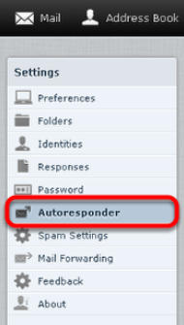

3. Complete the fields in the Autoresponder pane as follows:

- Click to put a checkmark in the box next to Enabled.
- In the Interval field, enter the number of days before the same recipient will receive the auto-response message again. If not specified, the interval defaults to one day.
- Click in the End Date field, and select the date when you want to stop the autoresponse message from being sent.
- In the Autoresponse Text field, type the message you want to be automatically sent in reply to all incoming email messages.

4. Click Save.

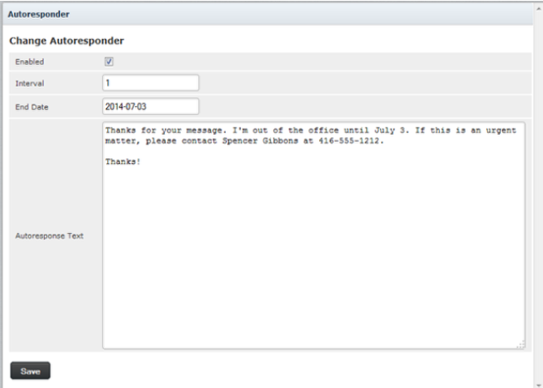

Changing your email password

This tutorial will show you how to change your email password while logged in to Webmail.

1. Click Settings.

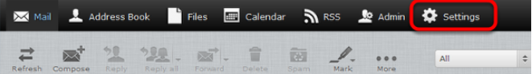2. Click Password.
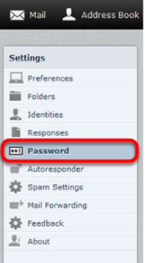

3. Enter your current email password in the Current Password field, enter your new email password in the New Password and New Password (again) fields, and then click Save.

What languages are available in Webmail?
Our webmail application is fully-localized in:

- English  - Danish  - Dutch  - German  - Greek  - French | - Italian  - Norwegian  - Portuguese  - Spanish  - Swedish

Full-localized means that all user interface elements, dialogs and in-line help are presented in the language selected.

Changing the Webmail language

This tutorial will show you how to change the language of your Webmail account page.

1. Click Settings.

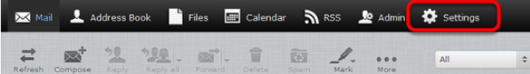

2. In the Settings pane, click Preferences, and then click User Interface.

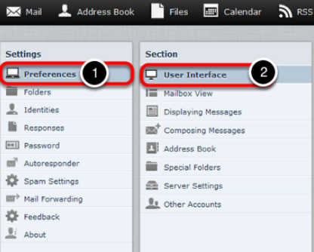

3. From the Language drop-down list, choose your language, and then click Save..

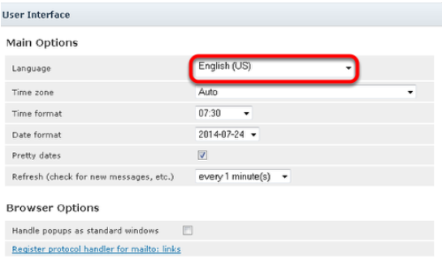

Setting the time zone

This tutorial will show you how to change the time zone in your Webmail account. It is important to keep this up-to-date if you are traveling, otherwise the time stamps on your emails will be incorrect.

1. Click Settings.

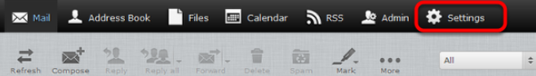

2. In the Settings pane, click Preferences, and then click User Interface.

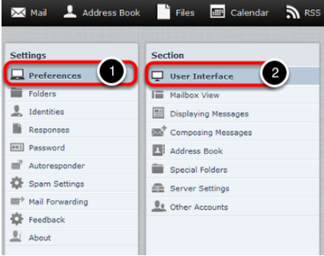

3. Next to Time zone, choose your time zone from the drop-down list, and then click Save.

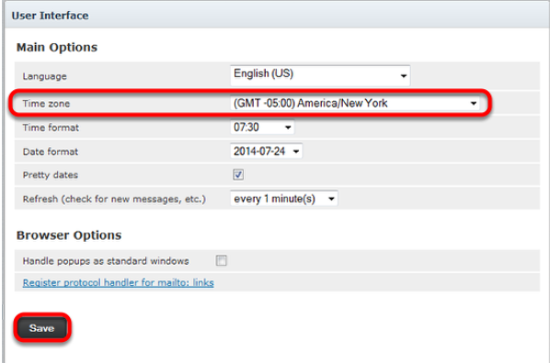

File storage and sharing files

File sharing allows you to share files outside of email. The largest file attachment you can send in your email is 25 MB. Using file sharing you can share or store a back-up copy of files larger than 25 MB. This tutorial provides an overview of the file storage feature.

Important: Files uploaded to Webmail count against your mail storage quota. If your email account has a 2 GB quota and you upload a 1 GB file, that leaves 1 GB of free storage quota for your email messages. In addition, there is a 2GB download limit for shared files in any 24 hour period - if you share a 500MB file and it is viewed four times, it cannot be viewed again for 24 hours.

To access your file storage, click Files in the Webmail header.

Uploading files

You can save up to 25000 files in the Files section, with up to 1000 files in any one folder.

Once a file is uploaded, you can share it with others by sending them a link to the file.

To upload a file

1. Click Files.

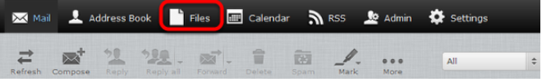

2. Optionally, select the folder where you want to store the file. If you don`t select a folder, the file will be stored at the top level, also known as the root.

3. Click the upload icon.

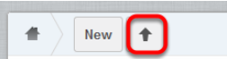

4. Browse to the file that you want to upload, select it, and then click Open.

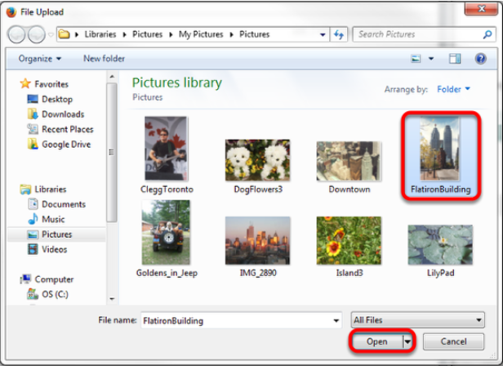

The selected file is uploaded to the folder that you chose in step 2.

Note: Large files may take a few minutes to upload.

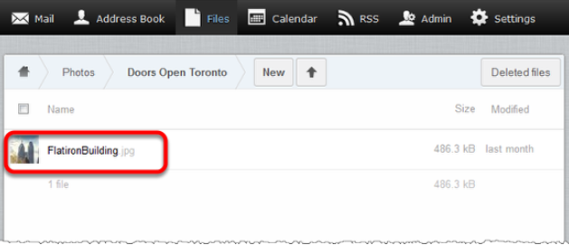

You can create customized folders to organize your files.

To create your own folders

1. In the Files section, click New, and then click Folder.

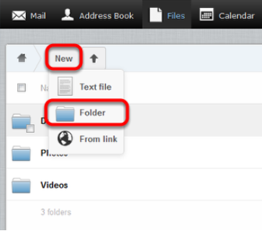

2. In the text box, type a name for the new folder and press the Enter key.

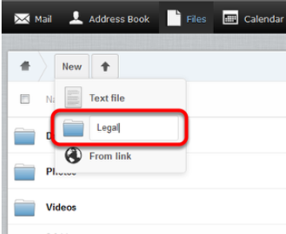

Your new folder is displayed in your Files list.

Sharing files

To share files

1. Mouse over the file that you want to share, and click Share.

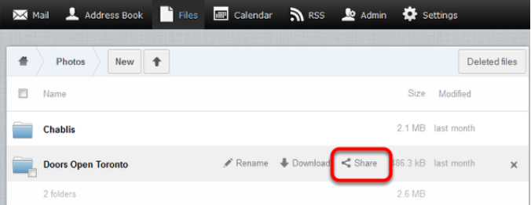

2. Click to put a check in the Share link box.

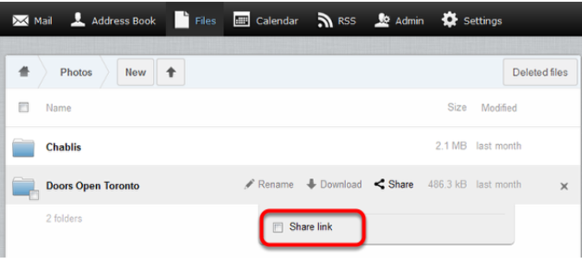

The box expands to display a link for the file.

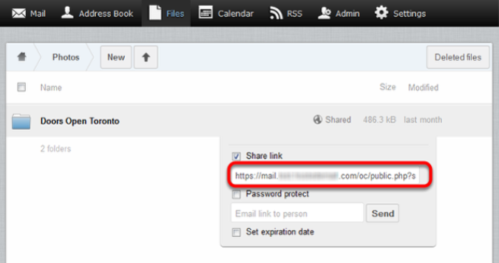

Highlight and copy this link.

You can now use the link to share the file over email, instant messenger, social networking, and so on.

If you want to email the link to a single address without having to copy it and then paste it into an email message, you can enter an email address in the Email link to person text file and click Send.

You can also put a check in the Set expiration date and choose the date when the link will stop working. When you click anywhere in the field, a calendar appears that allows you to choose the expiry date.

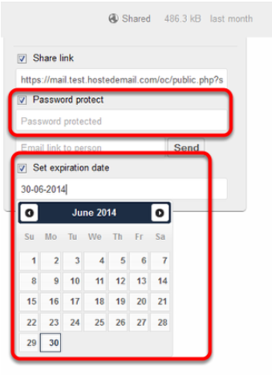

Restoring deleted email

Deleted email messages may be recovered by our customer service team if you contact us within 14 days of deleting the messages. Our engineering team saves back-up images of mailboxes to allow us to recover deleted email.

Note: We may be unable to recover your deleted messages if:

- The email was deleted within four hours of being received.
- Email that has been stored on our mail server for less than four hours may not have been included in a back up image.
- You download your email using a POP3 mail program.
- If you use a POP3 mail program and it is configured to download messages automatically and then remove copies from our server, we will be unable to save back-up images of your messages. We recommend that you switch to IMAP if you want us to be able to recover deleted email.

Customizing your spam settings
Adding a custom spam tag

By default, when a message arrives in your mailbox that Webmail identifies as spam, that message has a flag added to it, to indicate that it's spam. The spam flag isn't visible to you, but if you add your own custom tag, then all incoming spam messages will have your custom spam tag added to their Subject line.

To customize your Webmail's spam tag

1. Click Settings.

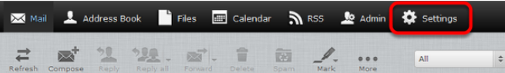

2. In the Settings pane, click Spam Settings.

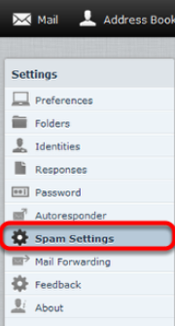

3. In the Subject Tag field, enter the custom spam tag that you want to use, and then click Save.
We recommend that you add a space or special character at the end of your tag so it does not run into the first word of the original subject line.

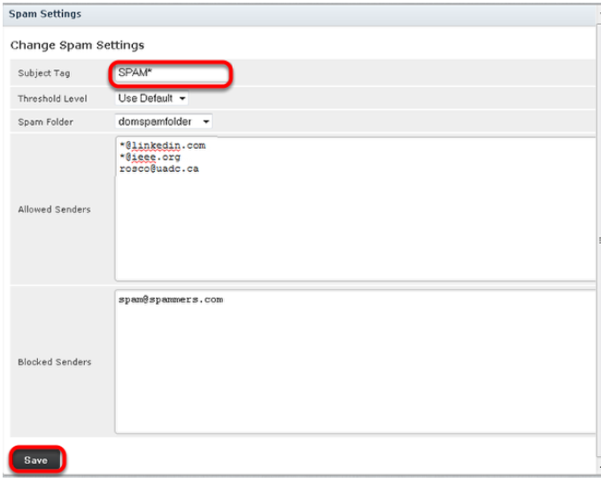

Any messages you download that are suspected of being spam will now have your custom spam tag in their Subject line and should be easy to identify.

Choosing a spam folder

By default, incoming spam messages are sent to your Spam folder. However, you can change the destination folder of incoming spam.

To change your destination spam folder.

1. Click Settings, and then click Spam Settings.

2. From the drop-down menu next to Spam Folder, select the folder where you want incoming spam messages to be delivered, and then click Save.

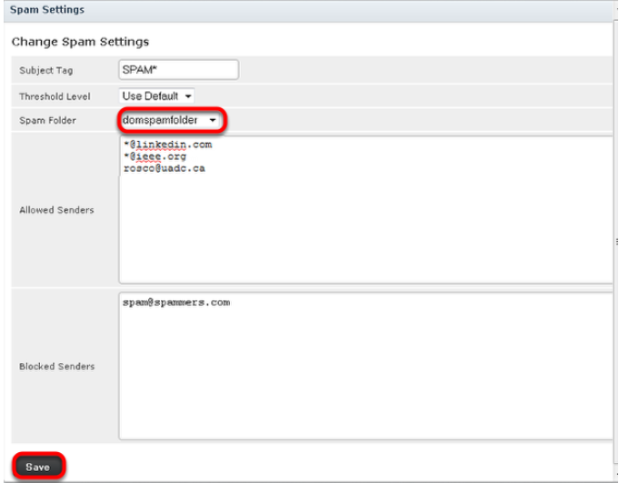

Choosing the spam block level

If you are receiving too much spam in your Inbox, or too many false positives in your Spam folder, adjusting the spam blocking level may help. The spam blocking level determines how likely it is that a message wil be marked as spam. A higher blocking level means messages are more likely to be marked as spam; however, you may also find that a lot of innocent messages are also classified as spam ( false positives).

1. Click Settings, and then click Spam Settings.

2. Choose the spam blocking level from the drop-down menu next to Threshold Level, and then click Save.

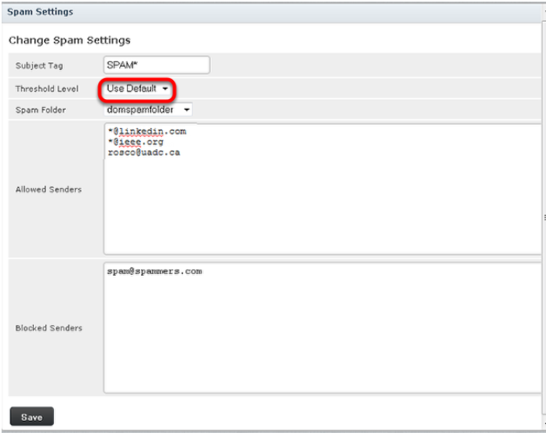

If you choose a level other than Normal, the spam filter will be more aggressive in classifying messages as spam.

If you choose Use Default, your mail will be filtered for spam using the level that is set for your domain.

If you choose High or Very high, more messages will be classified as spam; however, you may also find that a lot of innocent messages are also classified as spam. These messages are referred to as False Positives.

Using the calendar

The web-based calendar feature allows you to manage your schedule online in Webmail. This tutorial provides an introduction to the calendar's features.

To get started, click Calendar.

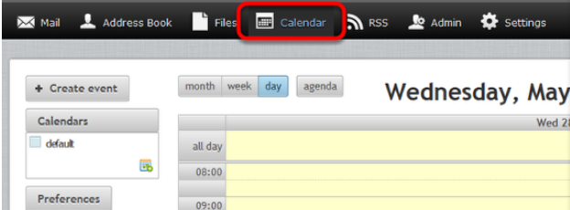

You can click Day, Week, Month or Agenda to view or add upcoming events.

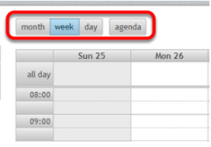

To add events to the calendar, double-click a time slot. You can then set details such as the name of the event, the location, and the duration.

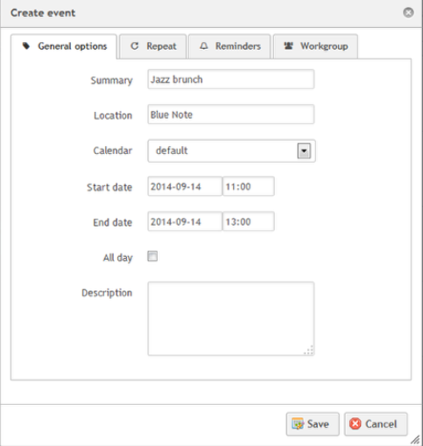

Click the Repeat tab to create a recurring event such as a weekly meeting.

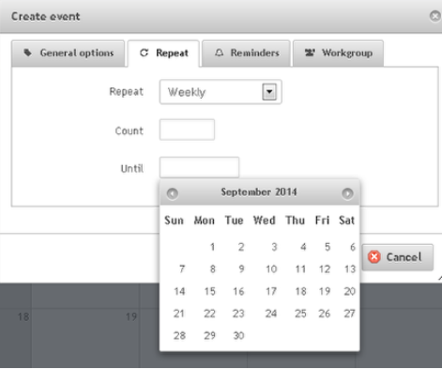

You can also set reminders to appear when the event is coming up. You can have reminders that are set at a specific number of minutes, hours or days before (or even after) the start or the end of the event, and you can set a reminder for a specific date and time.

Calendar Sharing

Calendar sharing allows you to share a calendar with another Hosted Email mailbox located on the same cluster. You can share a calendar by doing the following:

1. Click the Modify calendar icon next to the calendar you wish to share.

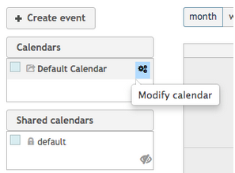

2. Enter the mailbox of the hosted email mailbox you wish to share the calendar with and click the + icon.

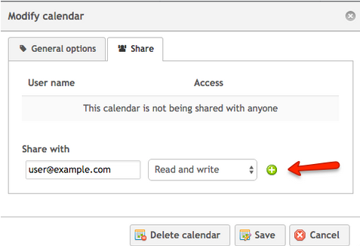

3. Click the Save button.

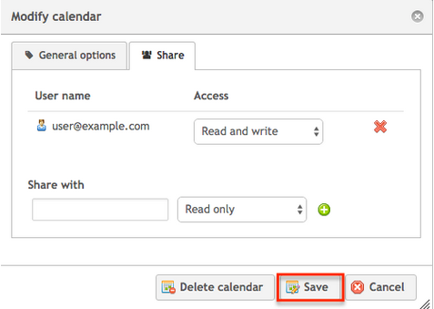

This user will now be able to see the calendar shared with them inside of their webmail interface.

Clearing the cache and cookies from your web browser

Your web browser stores temporary Internet files, which allow frequently visited websites to load faster, but these files may need to be deleted occasionally to free up space and remove old or corrupted files. If you are having trouble loading Webmail, it may help to remove your browser's temporary files. Click one of the links below to go to the instructions for the browser that you use:

- Internet Explorer
- Mozilla Firefox
- Google Chrome

Internet Explorer

1. Click the gear icon at the top of the browser, and choose Internet options.

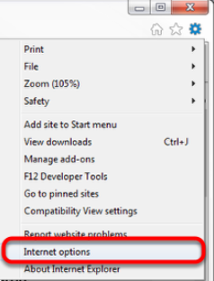

2. In the Browsing history section, click Delete.

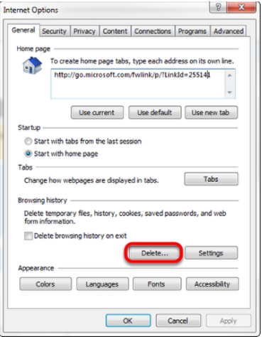

3. Click to put checkmarks next to Temporary Internet files and Cookies, and then click Delete.

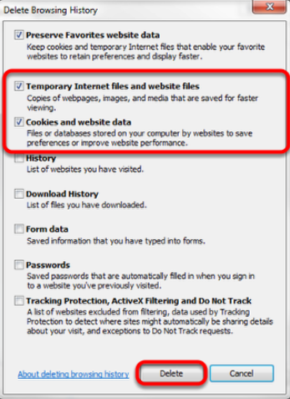

Mozilla Firefox

1. From the History menu, choose Clear Recent History.

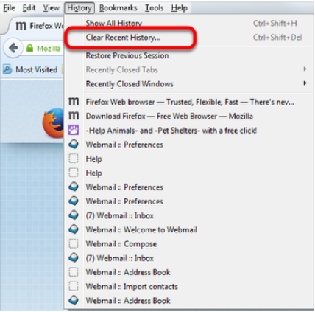

2. From the Time range to clear list, select Everything. Click to put checkmarks next to Cookies and Cache, and then click Clear Now.

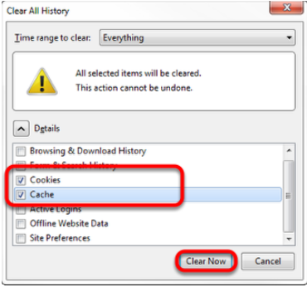

Google Chrome

1. Click the Chrome menu at the top of the page, choose Tools, and then choose Clear browsing data.

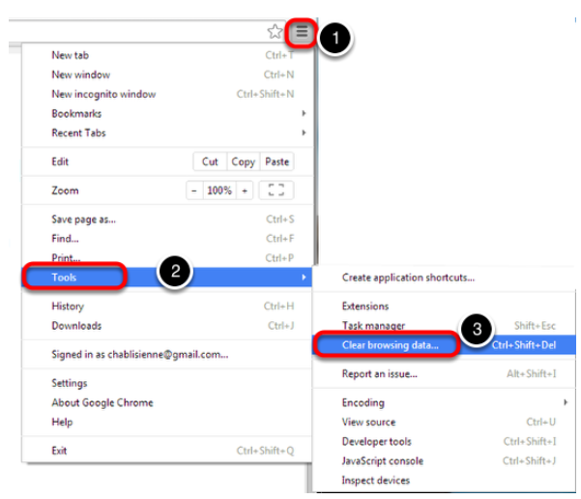

3. From the Obliterate the following items from drop-down list, choose the beginning of time, click to put checkmarks next to Cache images and files and Cookies and other site and plug-in data, and then click Clear browsing data.

